**Steps to login Nitj wifi**

**\*if you are facing an interface like this ….**

* **Go to the control panel.**

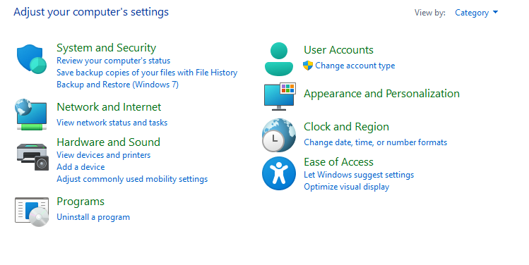

* **Click on network & internet.**

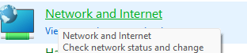





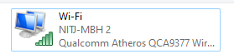Double click on network connection

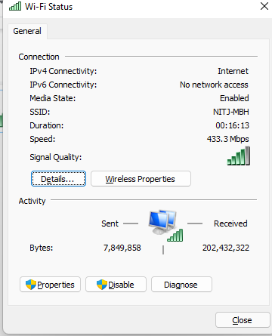**double click on properties ..**

**also double click on this line ..**

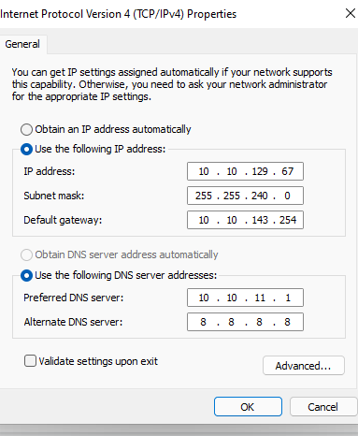

**After that paste the Ip address,subnet mask , Default gateway as given in your command prompt (cmd).just open cmd and type “ipconfig”. Hit enter..**

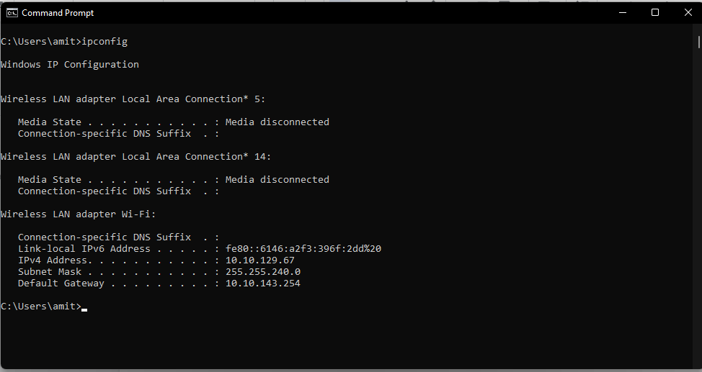

**Now goto the browser and refresh the webpage or type “10.10.11.1”..**

**You will get the nitj wifi login page**

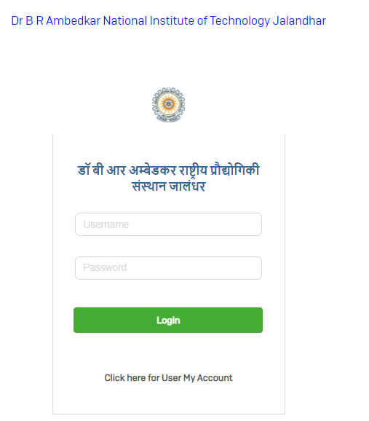

**Now , you are all set ..**

**Thank you…**